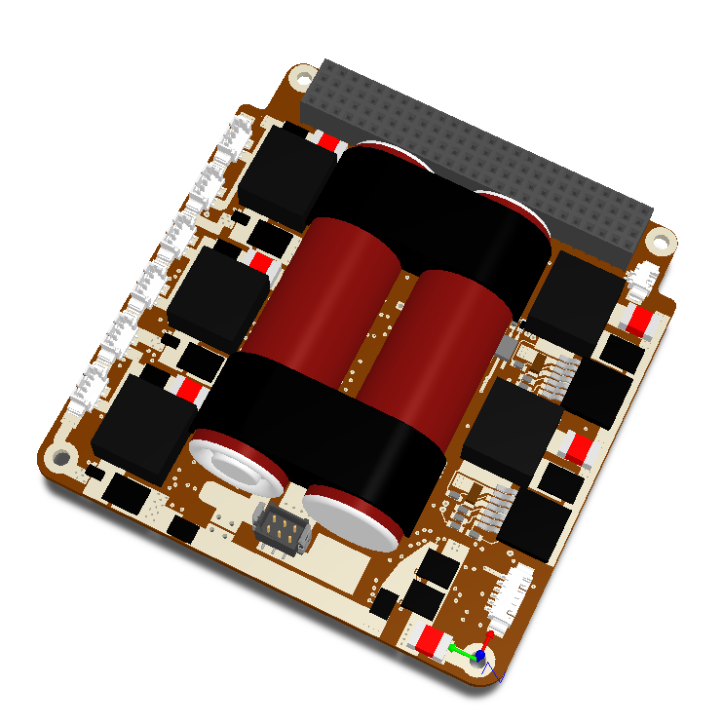

**Technical Specification of Gomspace PCB 2370**

Project name: nanopower-p31u-10

PCB ID: 2370

Specification version: 1

Replaces specification: -

Written by: Karl Kaas Date: 09.10.14

PCB designer Name: Karl Kass Design release Date: 09.10.14

Approved by: Approved Date:

1. Enclosure

Enclosed with this specification is a .zip file with extender gerber and netlist data files

and a .pdf file with artwork prints for identification purposes.

If inconsistency is observed between this specification and the attached data, the information

stated herein is valid and Gomspace needs to be notified.

For parameters not specified herein the defined standard below is valid.

2. Base specification:

|  |  |
| --- | --- |
| IPC-A600 cl.2 |  |
| IPC-6012 cl.2 |  |
| IPC-6012 cl.3 |  |
| IPC-6012 cl.3/A |  |
| IPC-6018 cl.2 |  |
| ESA ECSS-Q-ST-70-11-C | x |

3. Construction:

|  |  |
| --- | --- |
| Single/double sided |  |
| Multilayer | X |
| Rigid/flex |  |
| HDI multilayer 1-N-1, µvias |  |
| Other: |  |

4. Material type:

|  |  |
| --- | --- |
| Glass/polyimide (GI) IPC-4101/40 Arlon 85N | x |
| Glass/Epoxy (GF) IPC-4101/126 |  |
| Other: |  |

5. Design Parameter Values

|  |  |
| --- | --- |
| Board size: 93,17mm x 89,28mm | Layer count: 6 |
| Board thickness measured over bare substrate: 1.6mm | |
| Minimum Track Width: 200um | Minimum Hole Size: 300um |
| Minimum Spacing 150um | Minimum via pad size: um |

6. Solder finish:

|  |  |
| --- | --- |
| Hot oil reflow tin/lead | X |
| HAL leaded |  |
| HAL lead-free |  |
| ENIG |  |
| Other: |  |

7. Other processes:

|  |  |  |  |
| --- | --- | --- | --- |
| Soldermask liquid |  | Soldermask laminated |  |
| Notation upper side | white epoxy, low outgassing. | Notation lower side |  |
| Countersink | x | Goldplating |  |
| Copper fill requirement |  | Other: |  |

8. Test to perform:

|  |  |
| --- | --- |
| Electrical test: | X |
| Impedance test: |  |
| IST: |  |

9. Delivery panel information

|  |  |
| --- | --- |
| Delivery in panels: | Yes, nanopower-p31u-10-panelization.pdf |
| Panel size x – y: | 208.84mm x 205.56mm |
| Number of PCB’s in X: | 2 |
| Number of PCB’s in Y | 2 |
| Scrapped boards in panel accepted: | No |
| Panel construction contacts: | Necas A/S |

10. Packaging

Packaging to be separate one by one in antistatic bag, and then 10 into a bigger bag.

Mil-P-116G method 1A-8

**Appendix 1. Build-up**

Copper: 70u/70u

Thickness over bare substrate: 1.6mm

Files:

Top: nanopower-p31u-10.GTL

I1: nanopower-p31u-10.GP1

I2: nanopower-p31u-10.G1

I3: nanopower-p31u-10.G2

I4: nanopower-p31u-10.GP2

Bot: nanopower-p31u-10.GBL

top paste: nanopower-p31u-10.GTP

bottom paste: nanopower-p31u-10.GTBP

Drill: nanopower-p31u-10-Plated.TXT

Outline: nanopower-p31u-10.GM10

top notation: nanopower-p31u-10.GM7

**Counter sinking:**

1) Countersink the two holes shown below. Final diameter 5.0mm. Tip angle of bit: 90 degrees (to make 45 degree hole sides). Copper plated. SnPb finish.

